Cluster Scripts
Cluster_Code/
Read me
- To run simulated trials:
run_Calibrated_Trial_sim.sh #calibrated models
run_Marta_simulation_script.sh #Jama Network Open modes
Need to simulated trials in scenario (model) specific directors, e.g.:
Output/MARTA_sim/scenario_no_",scenario_no,"/MARTA_sim_results_", i, ".Rdata"))

- To add delay to simulated trials:
The following is a flow chart of the scripts required to run the analyses.
If run_master_delay.sh does not work, you can run
run_full_delay.sh, followed by combined_summary_delay.sh, followed by Delay_plots.sh.

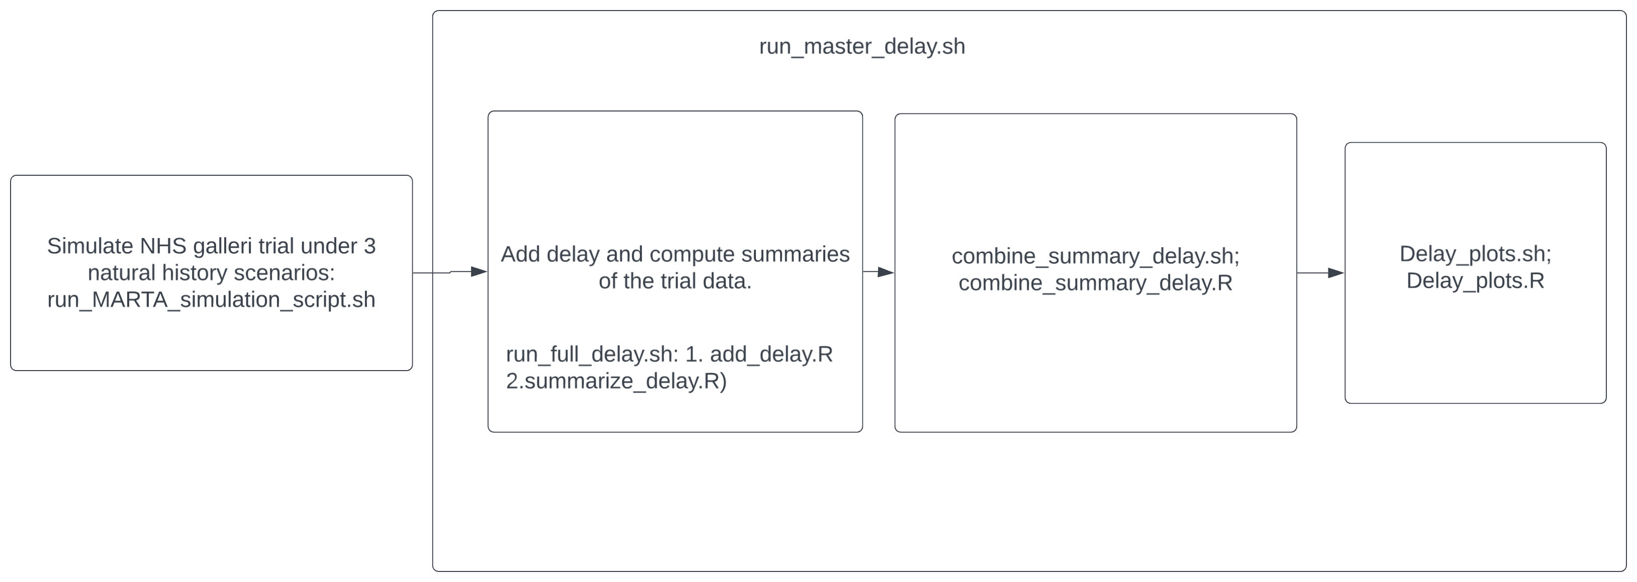
Processed Output data
Data/
all_delay_summary_cal.Rdata # contains all of output by random seed and cancer site for Models A-E (Note: Model A-B corresponds to scenario_no 4-5; C-E to scenario_no 1-3)
all_delay_summary_cal_sens_rates.Rdata # contains all of output by random seed and cancer site AND sensitivity analyses where post diagnosis rates were allowed to vary from 1,2,4.
Figures and Tables qmd for manuscript
Run this to generate svg and pdf files for the manuscript. Tables are generated in the html file in raw LaTex code—ready for copy/paste into Overleaf.
Reports/Figures_tables_calibrated.qmd

